

Report

Flanged Insert Jack-Out Test 5 May 2011

Battery-Gas Enclosure vs. Card Cage

Summary:

When screwing the Card Cage (S200-0003) …
Three screws were broken. The insert did not appear to move in the plastic, nor did the plastic show signs of stress.

Results:
- Screw 1, stainless panel screw, 4-40 UNC – hand snug, then tightened to break. Head twisted off – maximum torque 12 in-lbf.
- Screw 2, stainless panel screw, 4-40 UNC – hand tightened to a point that felt okay by hand.
  - The torque to start turning the screw was measured – first tester 6.5 in-lbf
  - Second tester torque measured 4.5 in-lbf
  - Turned to break point – turned down body broke between 8 to 12 in-lbf.
- .Screw 3, stainless regular screw (not panel) - hand tightened to a point that felt okay by hand
  - The torque to start turning the screw was measured – first tester 10 in-lbf
  - Second tester torque measured 9.5 in-lbf
  - Turned to break point – body broke between 15 to 20 in-lbf.

Conclusions and Recommendations:

The reverse mounted flange insert ...

Test Setup:

See Figures 01 to 04. The flanged threaded insert was heat-inserted into a sample of the battery-gas enclosure. A card cage mounting point was located over the insert, the screw started, then torque was applied tightening the screw to failure point. Two retained screws and one nominal screw were tested.

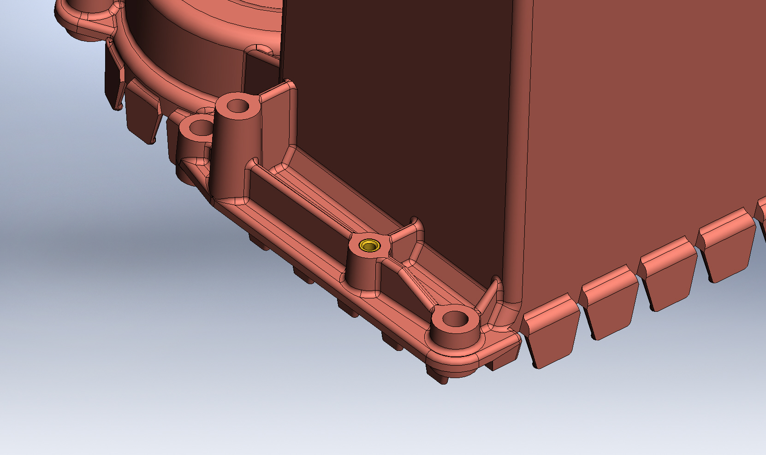
Insert
Battery-Gas Enclosure

Figure 01. Insert in battery-gas enclosure

Report prepared by:

George E. Riehm May 05, 2011
Nexus Design LLC
Oxford, CT 06478

